  
 **Muma College of Business**

School of Information Systems and Management

**A Project Report on**

**World Power Consumption**

**Prepared by:**

**Lakshmi Lavanya Javvadi**

**(U85351468)**

**Under the Guidance of**

**Professor Han Reichgelt**

## 

## 

## **University of South Florida** **Muma College of Business** **School of Information Systems and Management** **ISM6419. 792S23.24576 Data Visualization**

**INTRODUCTION:**

* Energy usage increases exponentially during the industrial revolution. We have been consuming energy without considering the environment currently. The globe began looking for other sources of energy as the extraction and processing of fossil fuels grew more difficult and could no longer satisfy the demand.
* At that point, nuclear energy was discovered. Although producing nuclear energy is simple, it is hazardous and has negative health impacts. We are concerned about global warming and have changed how we think about energy.
* Renewable energy was developed because of this. Renewable energy production has no negative environmental effects. The creation and study of renewable energy has come to the attention of the entire world.
* Over the last few centuries, the availability of energy has significantly altered the path of human history. We continue to develop innovative strategies for capturing the energy. Energy has first been drawn from fossil fuels, then from nuclear power, and finally from renewable sources.
* The demand for energy has grown because of technological improvement and population growth. Finding new sources of energy and developing existing technology are the subjects of extensive research and development.

I think the study that follows will provide us with information on how the globe is doing about energy usage.

1. Different countries installed capacities for different types of renewable energy.
2. Compare the energy or power consumed by all countries or continents with respect to the GDP and Population
3. Evaluate the various energy sources, such as nuclear power, renewable sources, and fossil fuels.

I'll be using publicly available datasets from a variety of sources, including the World Bank, ourworldindata.org, and several others, to provide insightful answers to the above concerns.

**Methodology:**

I have gathered numerous datasets from the sources mentioned above to respond to the stated inquiry.

1. Nuclear Energy dataset is collected from

<https://ourworldindata.org/nuclear-energy>

The dataset contained null and irrelevant values. The dataset was cleaned before being imported into the tableau. It includes information on nuclear energy consumption from 1980 through 2020.

1. Fossil fuel dataset was collected from the source

<https://ourworldindata.org/fossil-fuels>

There were irrelevant and null values in the dataset. Cleaned the dataset before importing into the tableau. It contains data about global fossil fuel consumption from the year 1980 to 2020

1. World GDP dataset is collected from the source

<https://data.worldbank.org/indicator/NY.GDP.MKTP.CD>

This dataset contains null values and irrelevant values. I cleaned the data using the tableau prep builder and done unpivoting for the table. This dataset contains GDP of each country from the year 1980 to 2020.

1. Information about the continents and the countries was gathered from the website This data source is attached to provide information at the continent, global, and national levels.

<https://statisticstimes.com/geography/countries-by-continents.php.>

1. Renewable Energy dataset was collected from the source:

<https://ourworldindata.org/renewable-energy>

The dataset contained useless and null values. Before importing it into the tableau, the dataset was cleaned. Data on Renewable energy consumption from 1980 to 2020 are included.

1. World population dataset was collected from the source:

<https://data.worldbank.org/indicator/SP.POP.TOTL>

The dataset included null and irrelevant values. before loading it into the tableau, I cleaned the dataset. Data on world population from 1980 to 2020 is included.

1. World energy dataset was collected from:

<https://data.world/datasets/energy>

This dataset contains data with respect to the countries and continents.

**Analysis:**

**Energy consumed w.r.t GDP:**

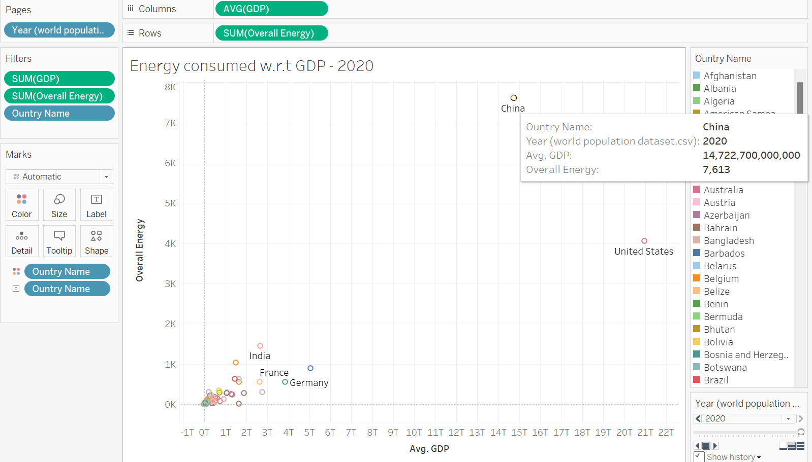

China used an average of 7,613 billion KWH of energy in 2020, according to a calculation of the Gross Domestic Product (GDP) for the amount of energy consumed by various nations.

**Energy Consumed w.r.t Population:**

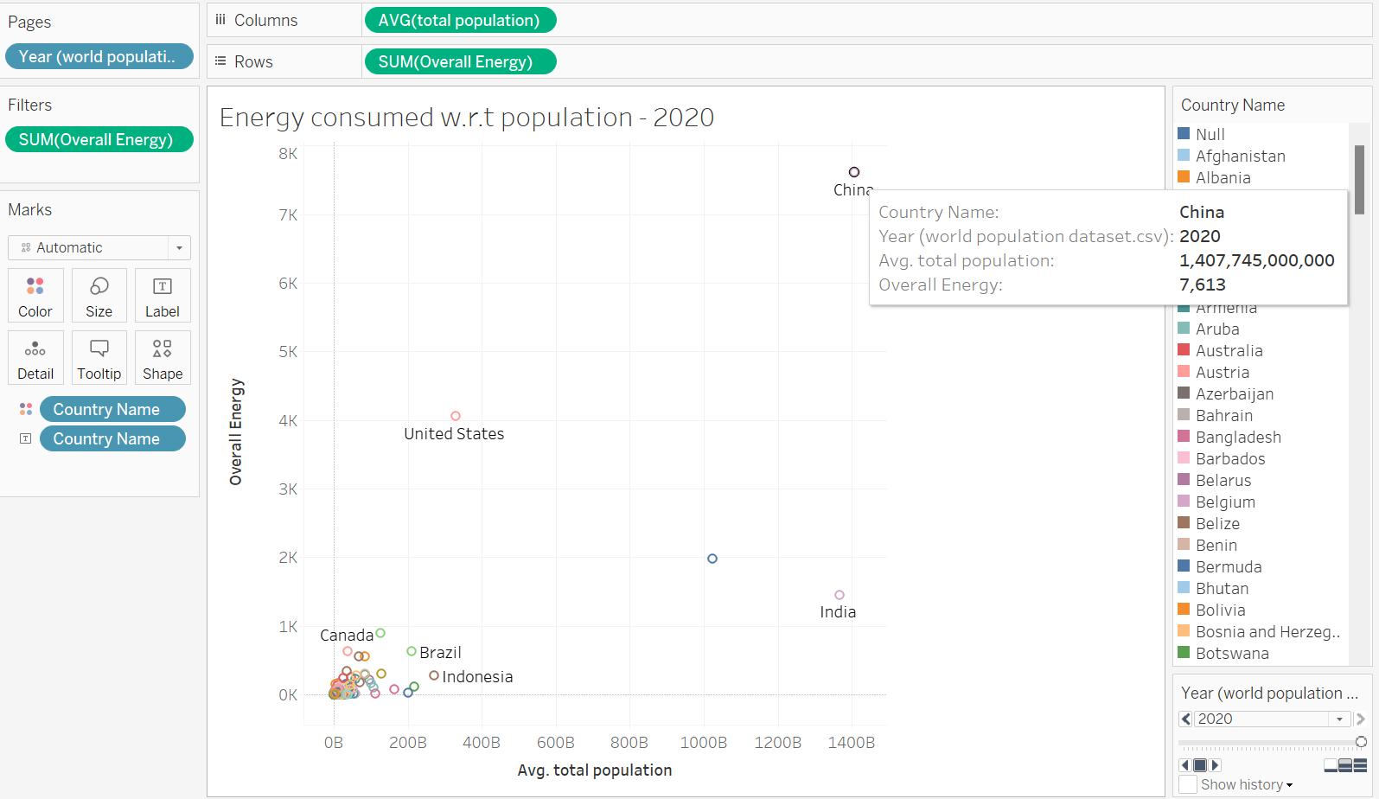

**In 2020, the energy consumed by total population, china has the highest consumption**

**Fossil Fuel Energy Consumption by country - 1980:**

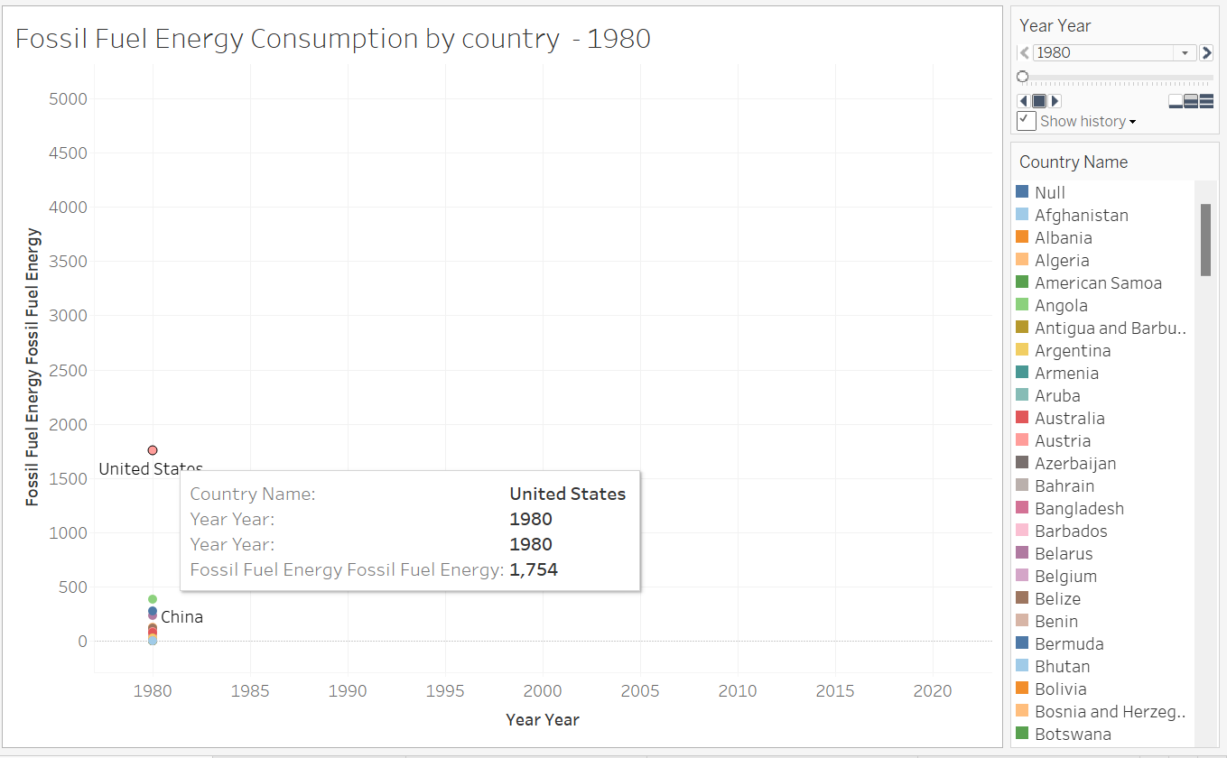

**Fossil Fuel Energy Consumption by Country- 2020:**

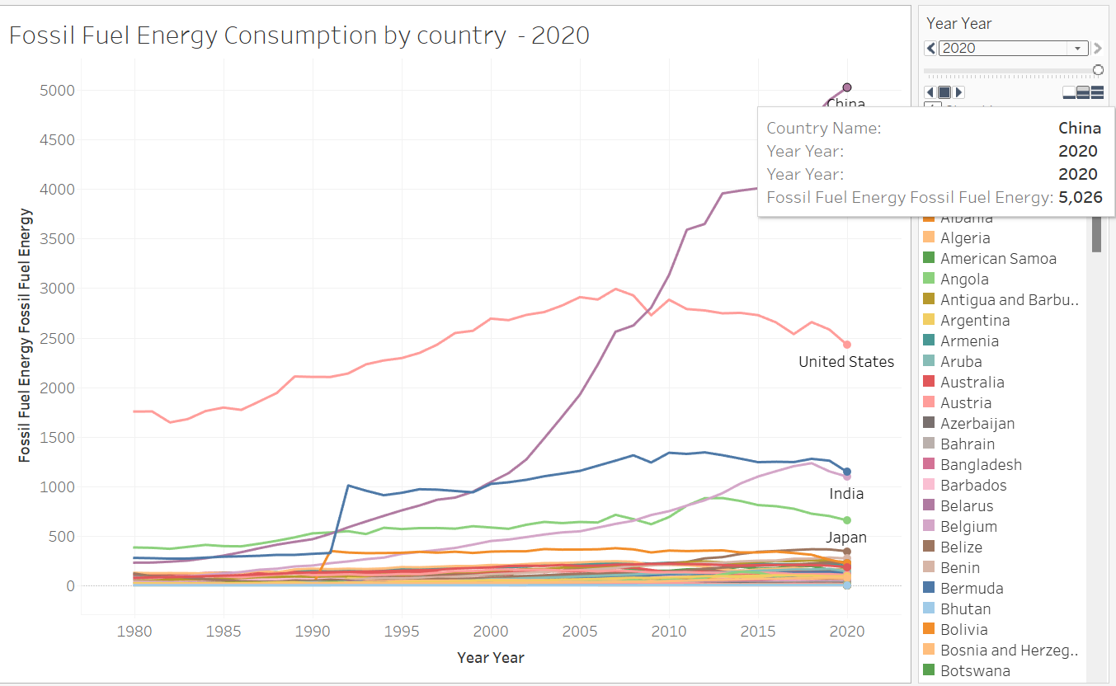

On the chart above, we can see how much fossil fuel each country used from 1980 to 2020.

• The USA initially consumed the most energy from fossil fuels, amounting to 1754 billion KWH, but by 2020 China had overtaken the USA as the country consuming the most energy from fossil fuels, amounting to 5026 billion KWH. I also added the pages animation in which the trail option allows to see the graph change from year to year

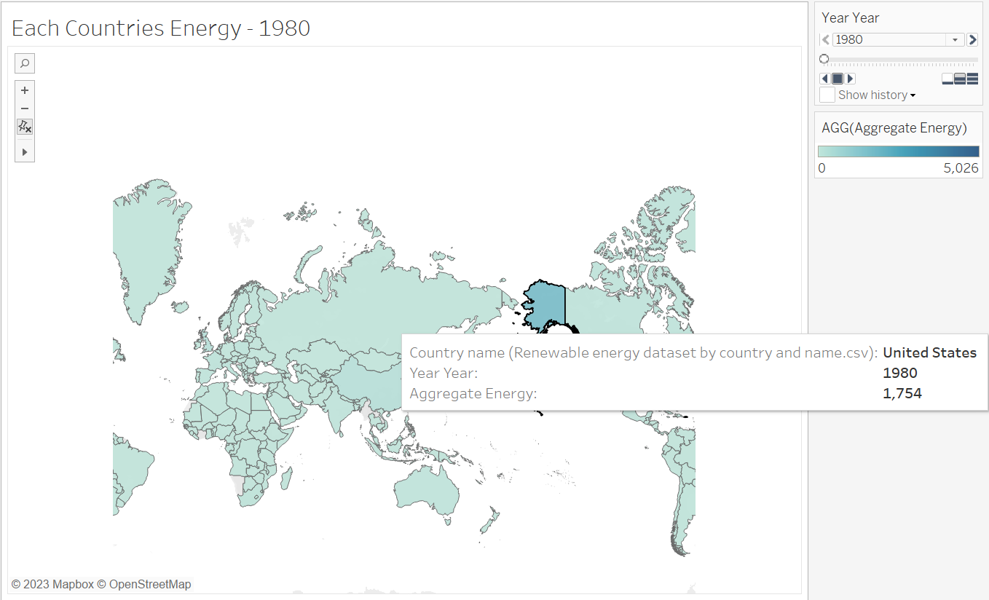

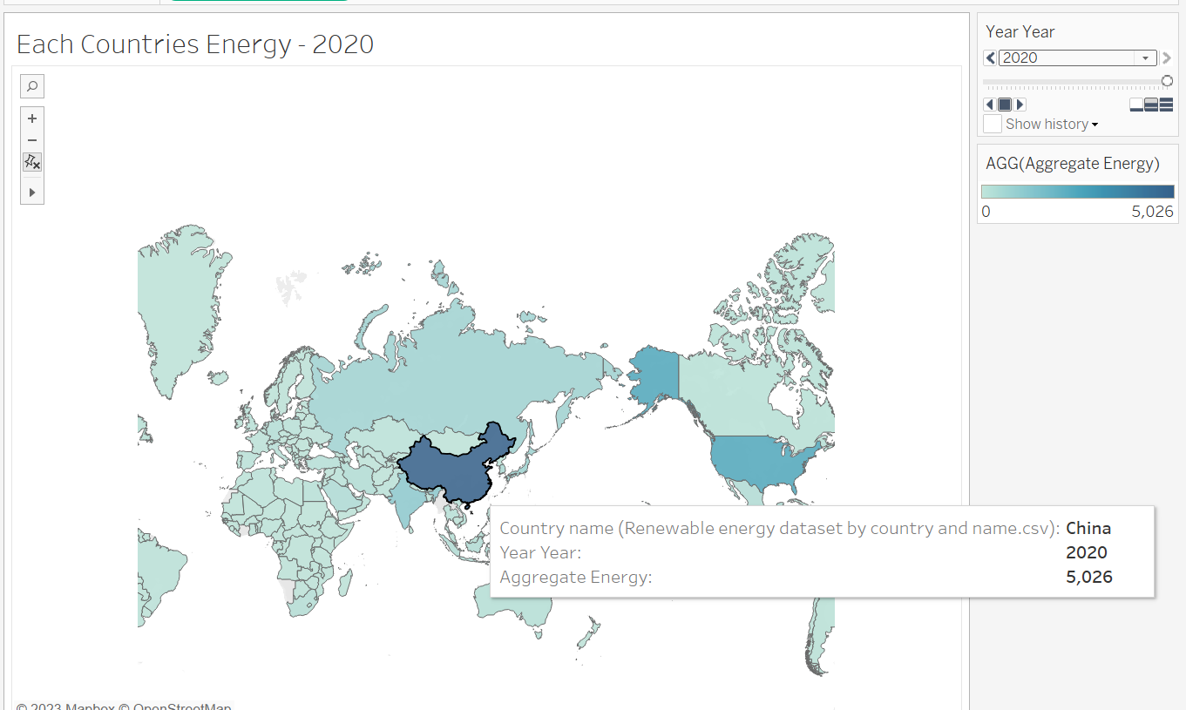

The above map shows the fossil fuel energy of each country. At first USA has the highest fossil fuel energy consumption of 1754 billion KWH. But China has increased its use and it has 5,026 billion KWH use of energy. The use of fossil energy was increased by China from 1980 to 2020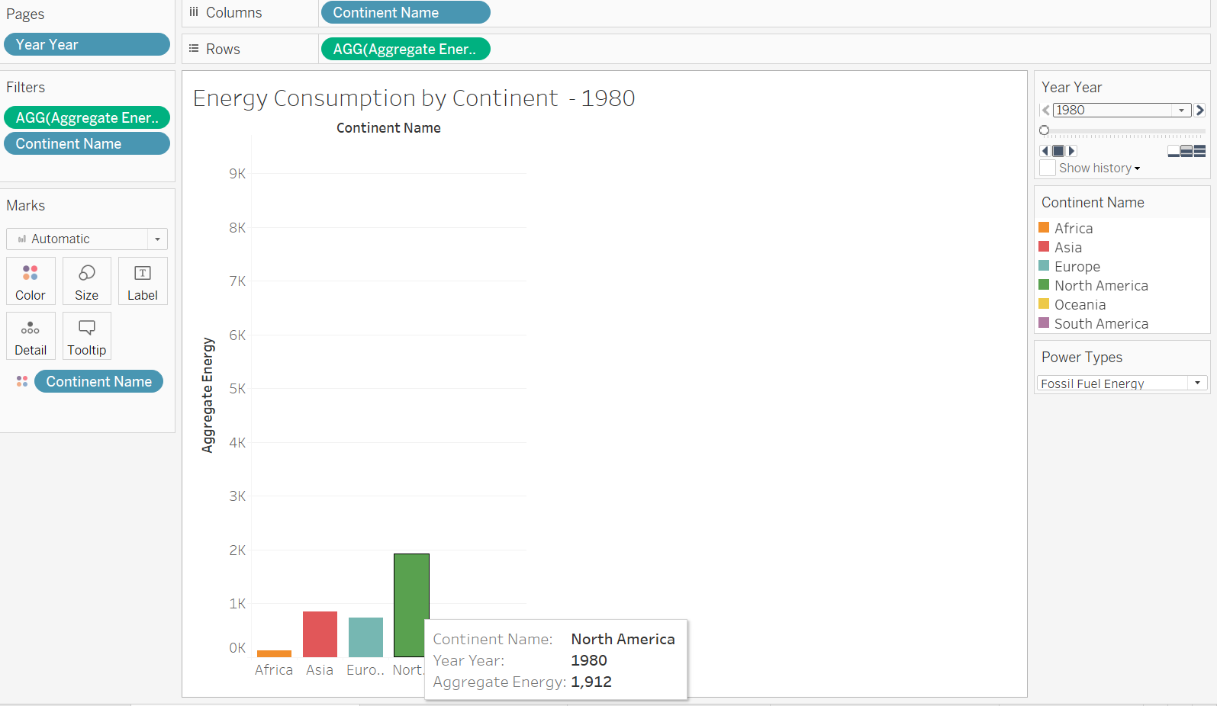

.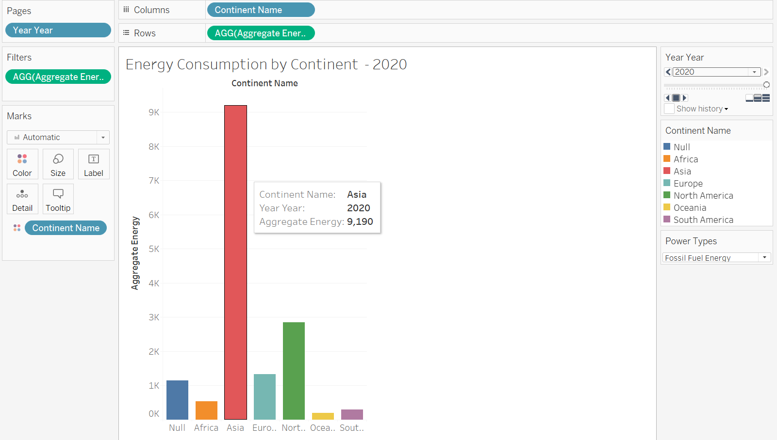

The energy used from fossil fuels between the years 1980 and 2020 is displayed in the bar graph above.

Initially, North America utilized the most fossil fuel energy, followed by Asia and Europe, and by the year 2020, Asia overtook North America and Europe as the biggest consumers.

The results are as follows when we normalize by dividing the energy by per capita income.

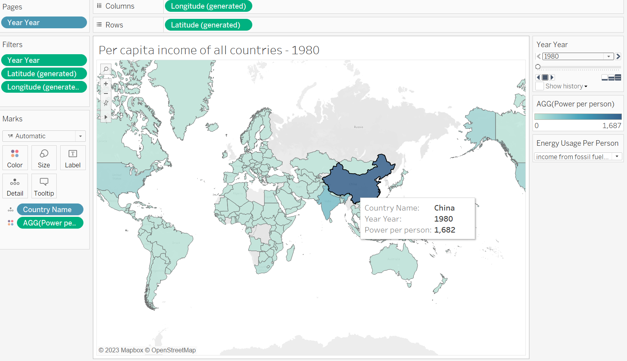

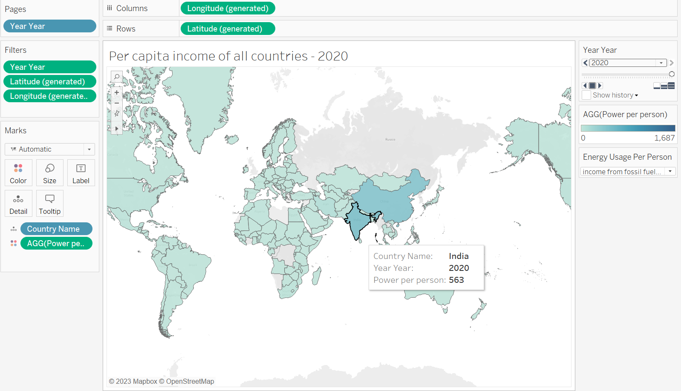

From the two charts, China consumed the most fossil fuels per capita in 1980. This was brought on by China's fast industrialisation and economic expansion during the time. But by 2020, India has surpassed China as the nation with the biggest per capita energy consumption of fossil fuels. This is largely because of India's vast population, which results in a lower per capita income despite a reasonably high GDP.

**Nuclear Energy Consumption:**

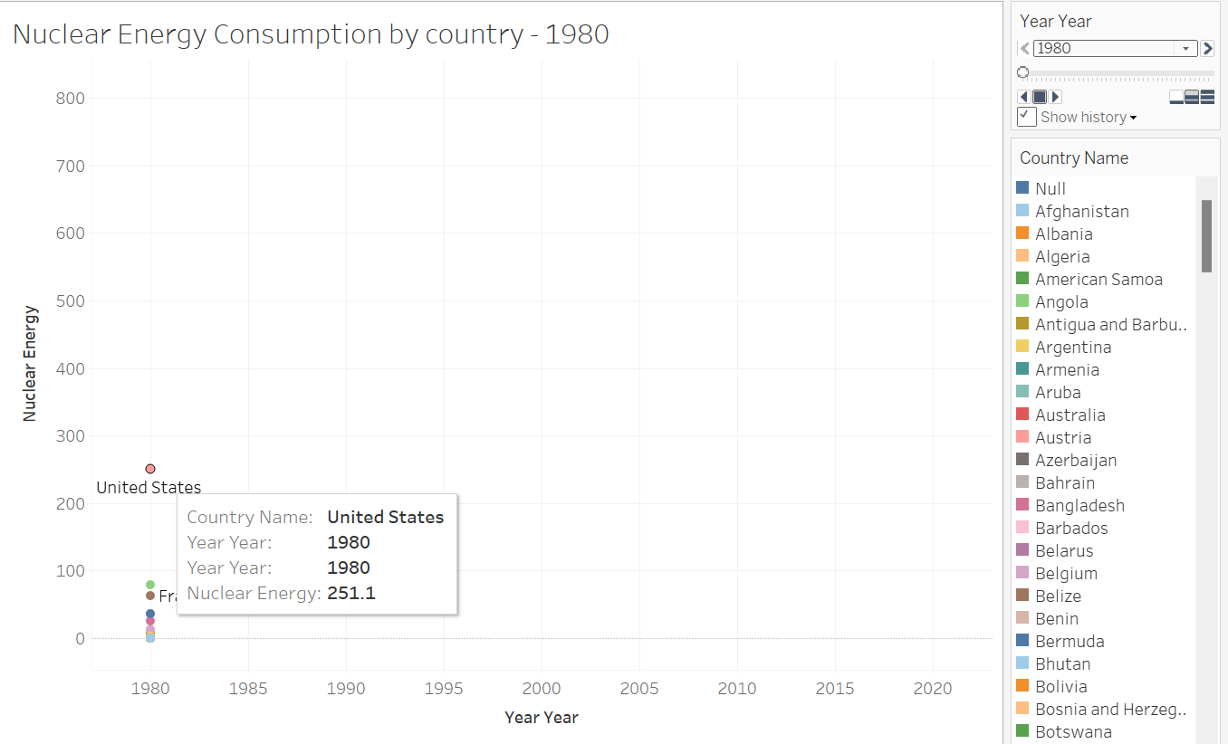

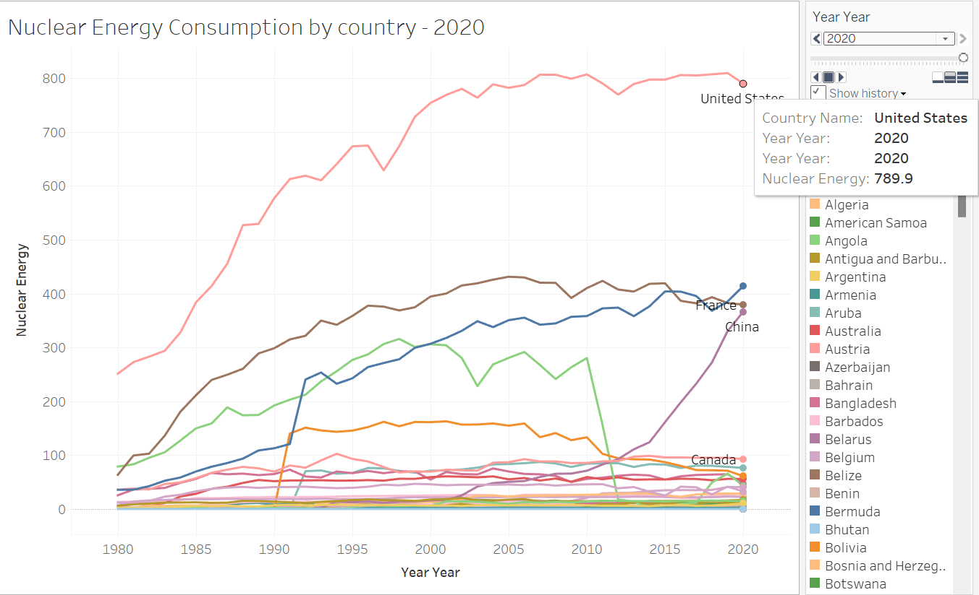

From the above graphs, we can say that USA has the highest nuclear energy consumption in 1980 with 251.1 whereas in 2020 the same was continued and USA has the highest consumption with 789.9

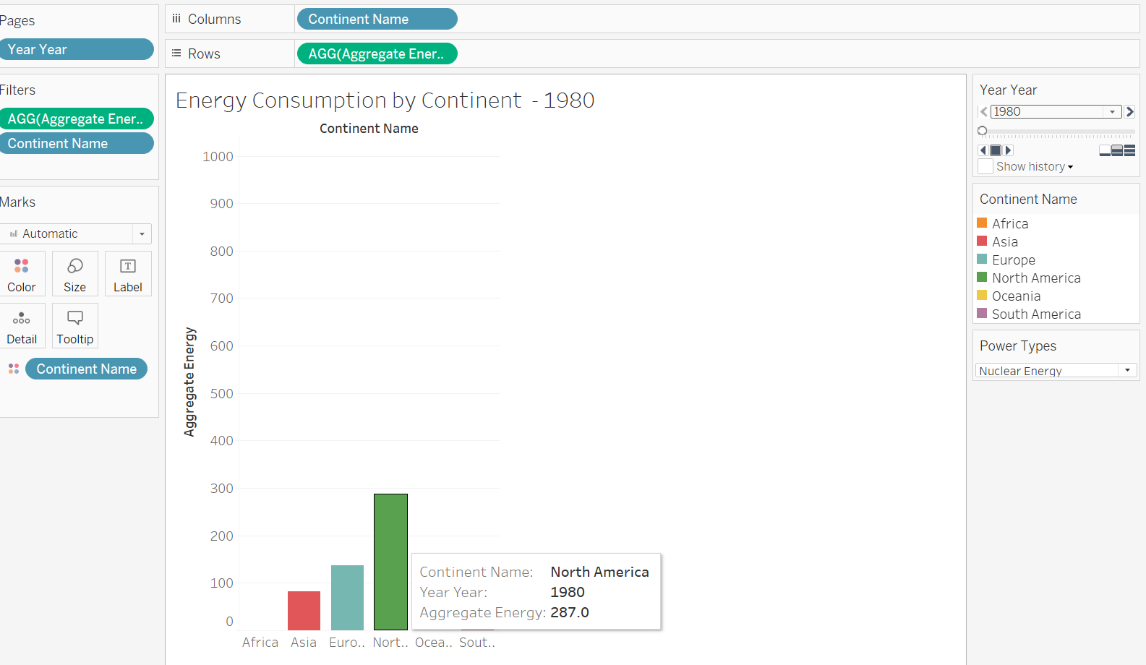

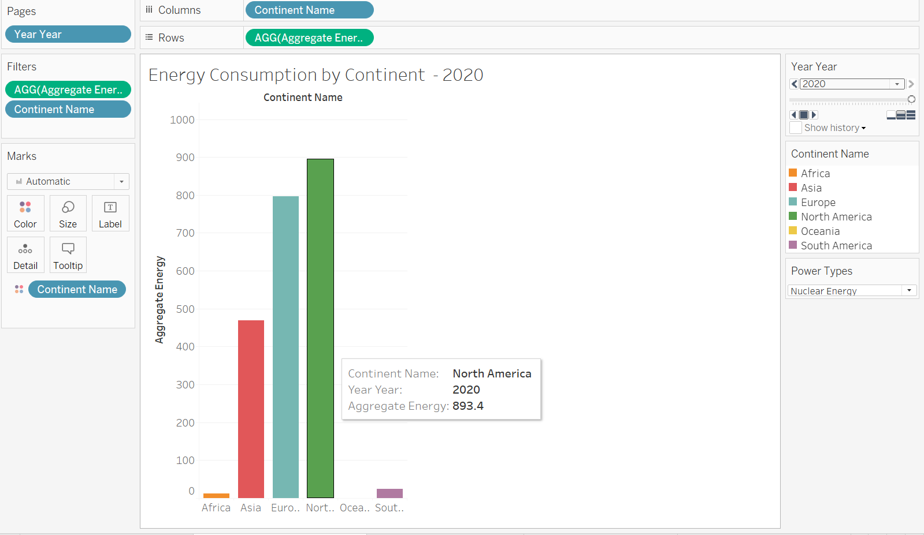

According to the graphs above, North America consumed the most nuclear energy per continent in 1980, followed by Europe and Asia. By 2020, however, North America's consumption had increased along the same trajectory as that of Europe and Asia.

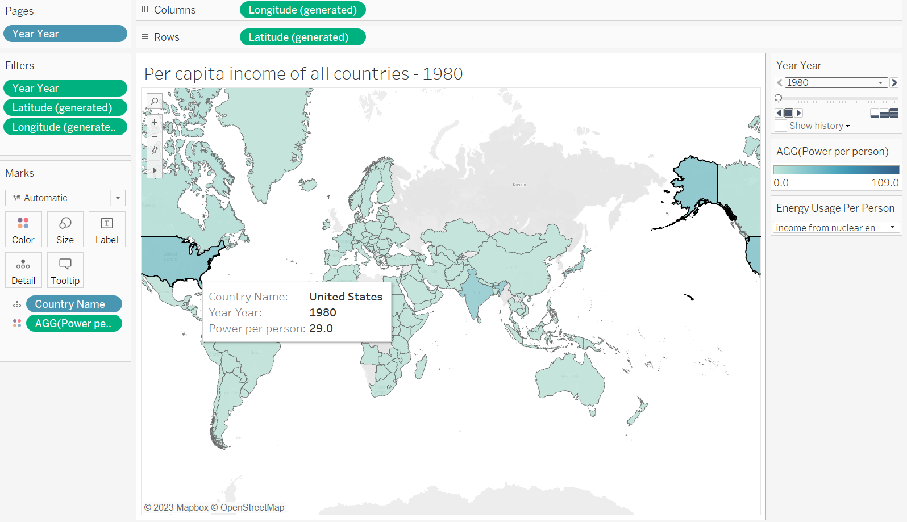

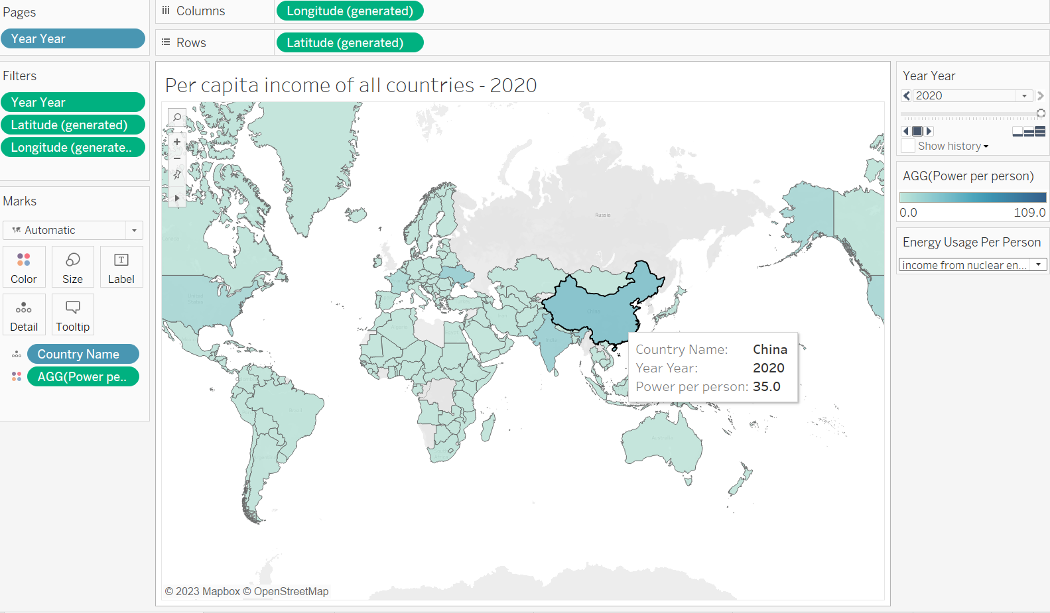

In 1980, the USA had the highest ratio of nuclear energy to per capita GDP. In comparison to all other countries shown on the map, the United States had the highest per-person nuclear energy production in that year. This shows that the United States was a major producer of nuclear energy in 1980 and that the country enjoyed economic prosperity at the time.

In terms of nuclear energy and per capita GDP, China led the world in 2020. In compared to all other countries shown on the map, China produced the most nuclear energy per person in the year 2020, according to this data. This indicates that China has advanced significantly in the generation of nuclear energy and that it has recently developed into a global economic powerhouse.

**Renewable Energy:**

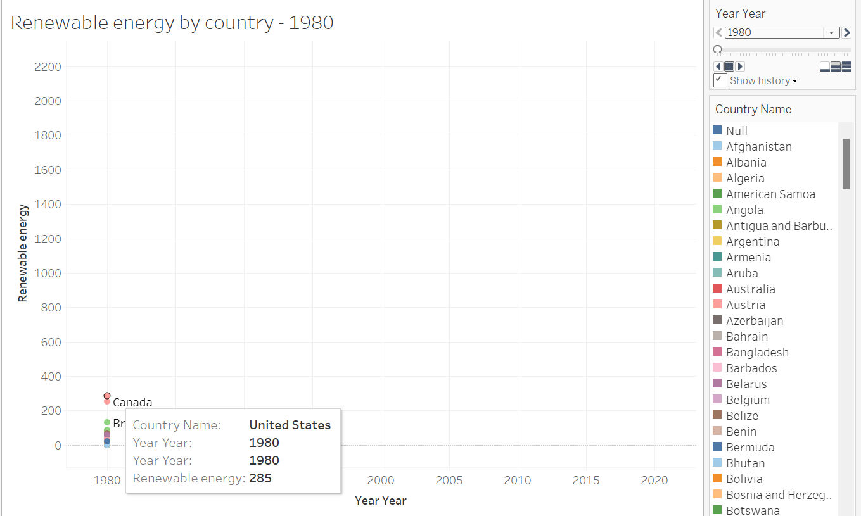

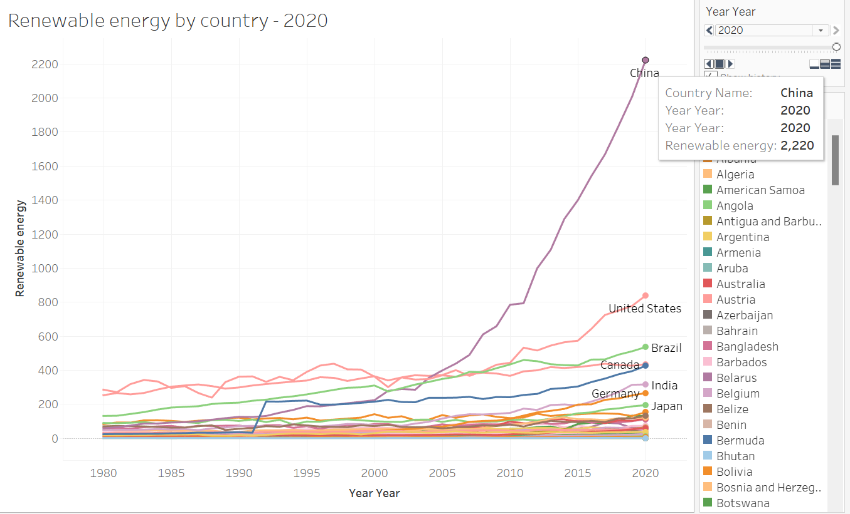

The United States consumed the most renewable energy in 1980, with a value of 285 billion kwh, according to the map. This can be assigned to the USA being one of the most industrialized nations at the time, with a strong demand for energy to support its expanding economy. With a value of 252 billion kwh, Canada came in second, which is also extremely significant when compared to other nations. The consumption of renewable energy is comparatively lower in other countries on the map.

Moving onto the second map, in 2020, China has the highest renewable energy consumption with 2,200 billion KWH

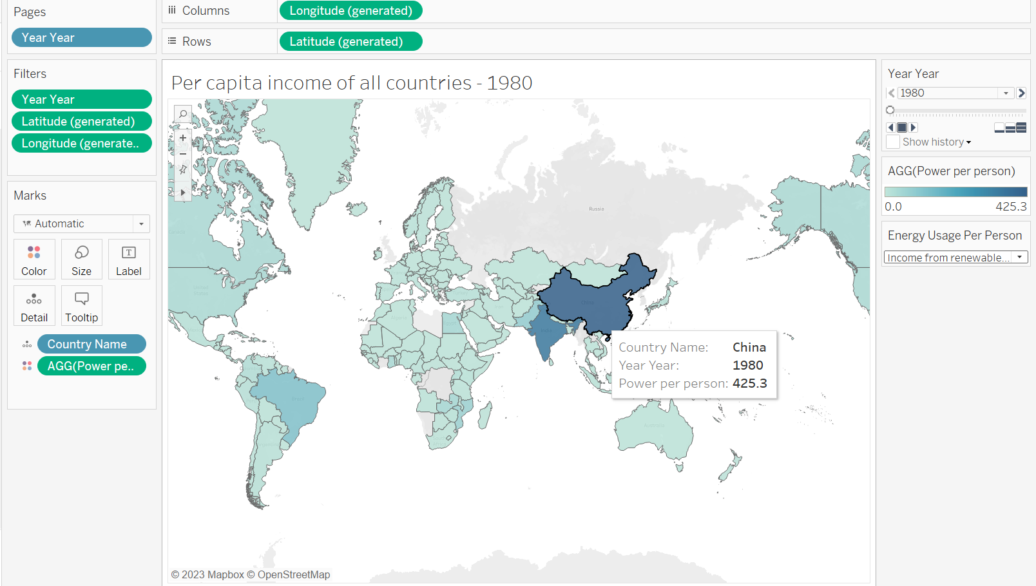

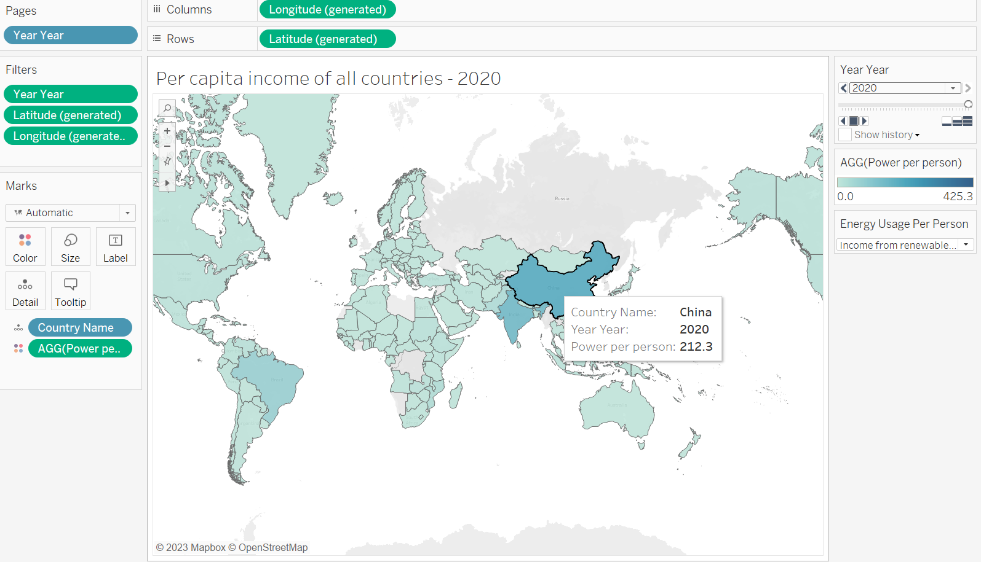

From the above maps the country China has the highest per-person earnings of renewable energy from 1980 to 2020 when compared with other countries. The consumption was decreased because, despite being straightforward, nuclear energy production is risky and harmful to health. Because of our concern over global warming, our views on energy have shifted.

**Country Energy Consumption:**

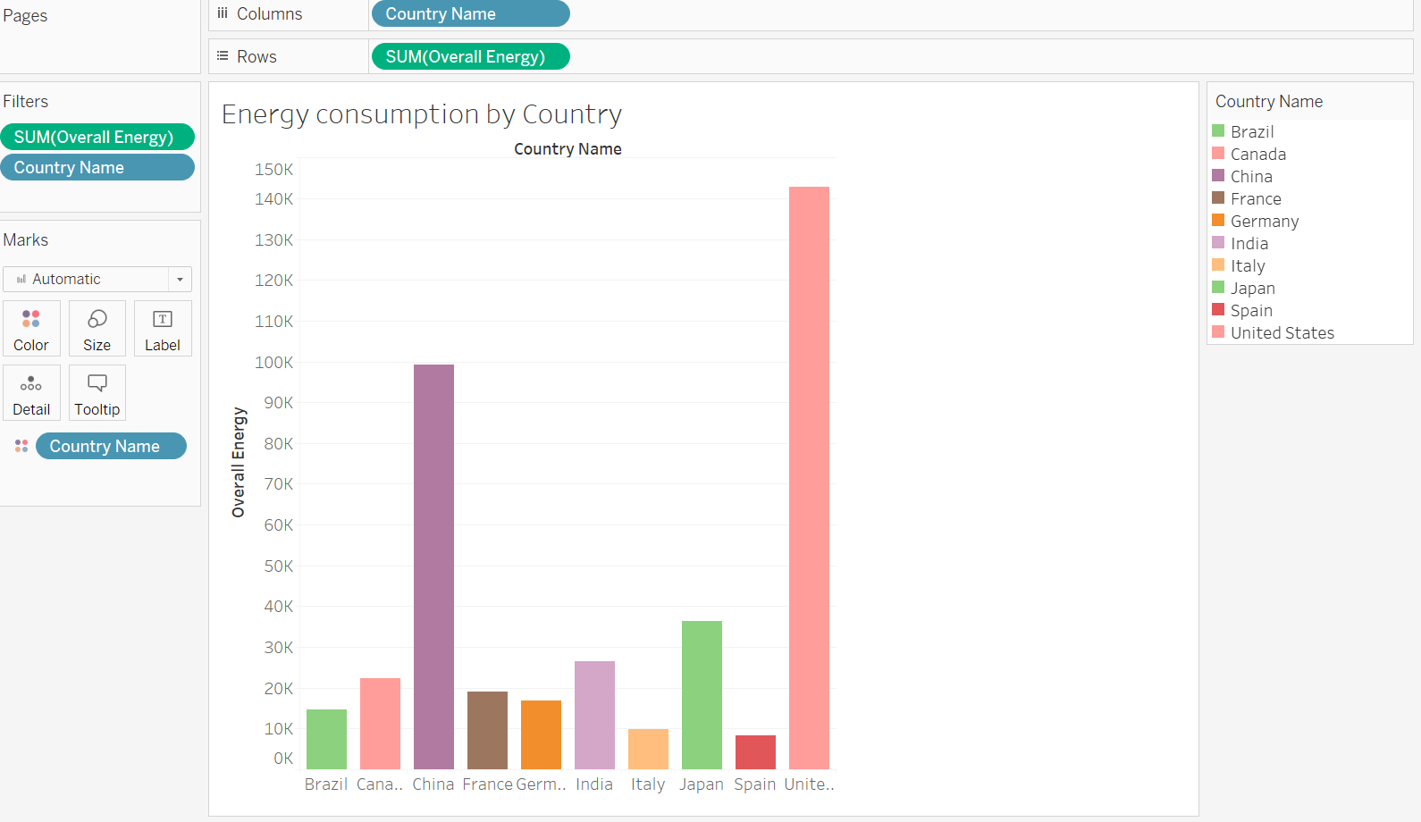

The graph uses a color-coded scale to show the total energy usage of each nation from 1980 to 2020. The chart shows that for the previous 40 years, the United States has been the world's biggest energy consumer. Over the past few decades, China has risen to become the second-largest energy consumer in the world. Since the early 2000s, the nation's energy consumption has sharply expanded along with its quick economic development and industrialization.

**Energy Global Consumption:**

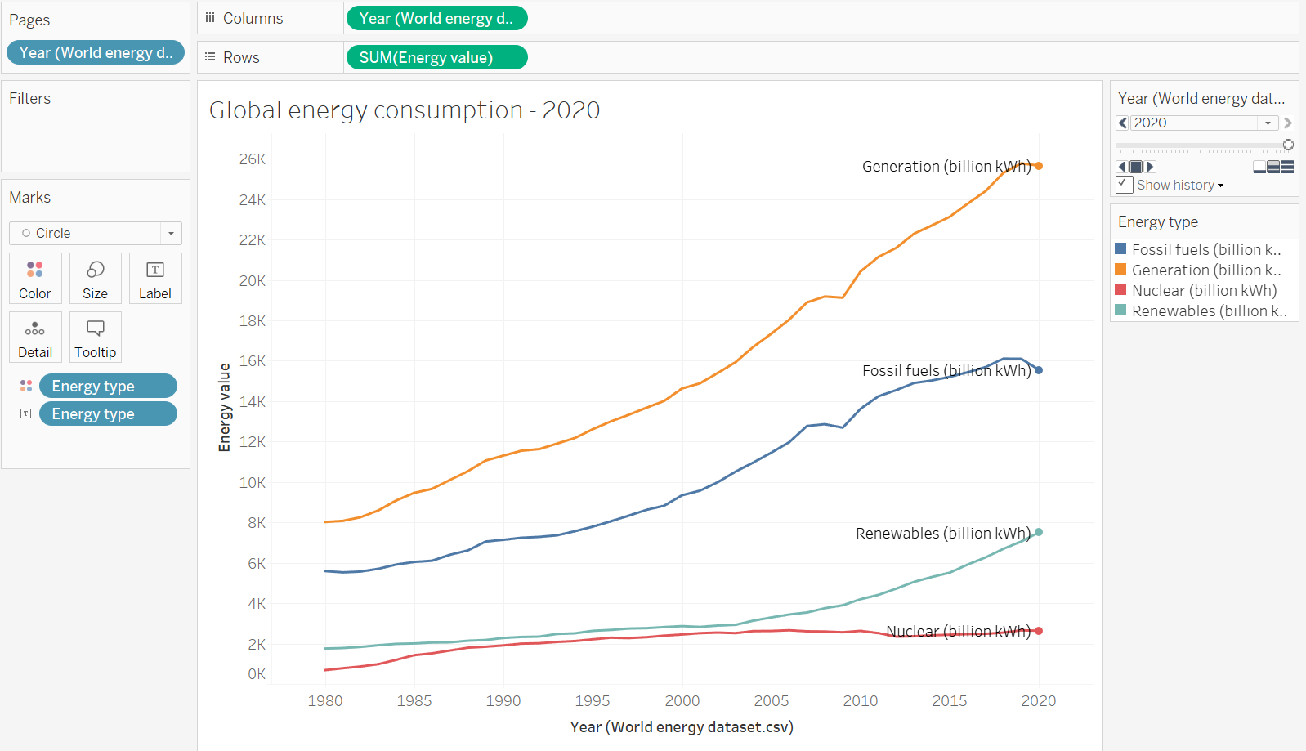

The data on the total amount of energy produced over a 40-year period, from 1980 to 2020, as well as the sources from which it was created, are shown in the line graph. From beginning to end, the total energy generated climbed practically linearly. The graph shows that by 2020, over 16 quadrillion British thermal units (BTU) would have been produced, up from roughly 10 quadrillion BTU in 1980. This demonstrates an ongoing rise in energy use over time.

Nearly 20% of the total energy generation came from renewable sources. The graph demonstrates that until 2003, there was little change in the generation of renewable energy. However, the output of renewable energy increased exponentially after 2003.

The graph demonstrates that during the 40-year period, nuclear energy produced about 5% of all energy. A consistent form of energy that offers a steady and dependable energy supply has been nuclear energy.

**Conclusion:**

From the above maps and graphs, we can answer the following questions.

1. **Different countries installed capacities for different types of renewable energy.**

In general, the maps clearly demonstrate that the use of renewable energy has expanded dramatically over the past few decades in many countries, with some countries making much more progress than others. China's domination in the use of renewable energy in 2020 is noteworthy and demonstrates that the nation is making great progress toward a more sustainable future.

By analysing the data, China continuously uses more renewable energy per capita than any other nation on the globe. China demonstrated a noteworthy dedication to renewable energy even in 1980, despite having a very low per capita GDP. China continued to invest in sustainable energy sources as the years went by and its economy grew rapidly; as a result, the country's use of renewable energy increased with time.

Countries with greater commitments to sustainable energy sources typically have higher per capita income levels, supporting the notion that the use of renewable energy can accelerate economic growth in a nation.

1. **Compare the energy or power consumed by all countries or continents with respect to the GDP and Population**

Over the course of the 40-year period, a large portion of the total energy produced—roughly 75%—was derived from fossil fuels. This demonstrates how heavily fossil fuels are used to supply the world's energy needs. The overall percentage of fossil fuel energy has decreased recently, nevertheless. The graph demonstrates that until 2003, there was little change in the generation of renewable energy. However, the output of renewable energy increased exponentially after 2003. The introduction of legislation intended to promote cleaner and greener energy sources as well as the growing knowledge of the environmental effects of fossil fuels are both responsible for this increase in the production of renewable energy. The data reveals that although global energy consumption has continuously increased over time, there has been a noticeable shift in Favor of cleaner, more environmentally friendly energy sources, particularly renewable energy sources.

1. **Evaluate the various energy sources, such as nuclear power, renewable sources, and fossil fuels.**

The analysis also shows that industrialized nations with plentiful access to technology produce more renewable energy. Germany, the United States, Japan, and the United Kingdom have all made large investments in renewable energy sources. As a result, their reliance on fossil fuels has decreased, as have their greenhouse gas emissions. On the other hand, the demand for energy in developing nations is rising and is mainly satisfied by non-renewable sources.

The project also emphasizes that there are just a few countries that produce nuclear energy, and that it has not increased significantly over the past forty years. This may be due to several issues, including safety, waste management, and the high expense of constructing and operating nuclear reactors. However, some nations, including France and Japan, have been successful in producing a sizable portion of their electricity using nuclear energy.

The initiative has helped us grasp the trends in the world's energy use very well. It demonstrates how higher GDP nations like the USA, Russia, China, and India use more energy than other nations. This may be due to a number of things, including industry, urbanization, transportation, and residential energy use.

**Additional Research questions:**

Apart from the above research questions,

1. What reasons are anticipated to drive these changes in energy consumption rates, and how are they predicted to change in the future?
2. What are the effects of global energy consumption on the environment, and how can they be reduced?
3. How does energy use impact economic expansion, and can the creation of clean energy act as a spur for it?